Final Lab 8

Anurag Sharma

College of Computing and Digital Media, DePaul University

NET 577: Network Security II

March 19, 2025

# **Screenshot of a LDAP Configuration on Authentik**

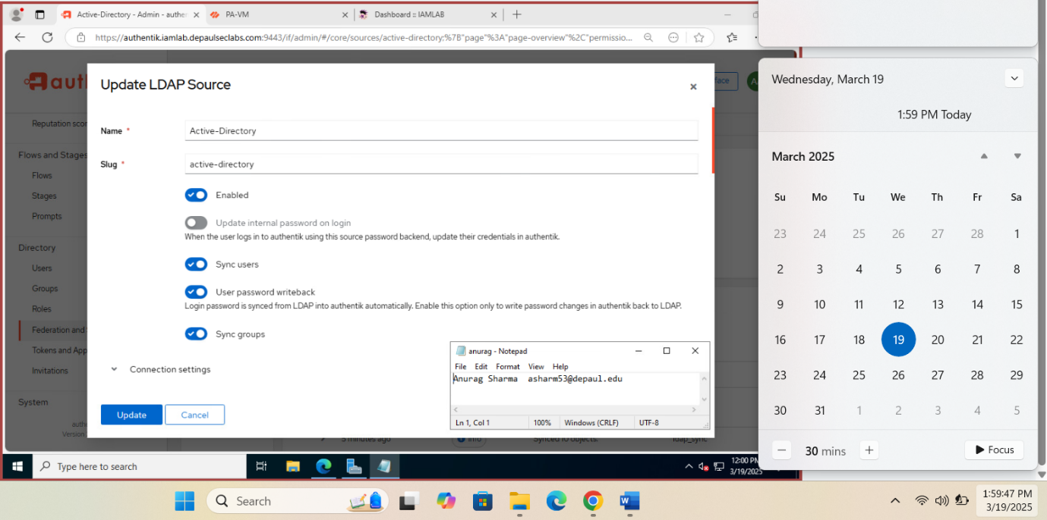

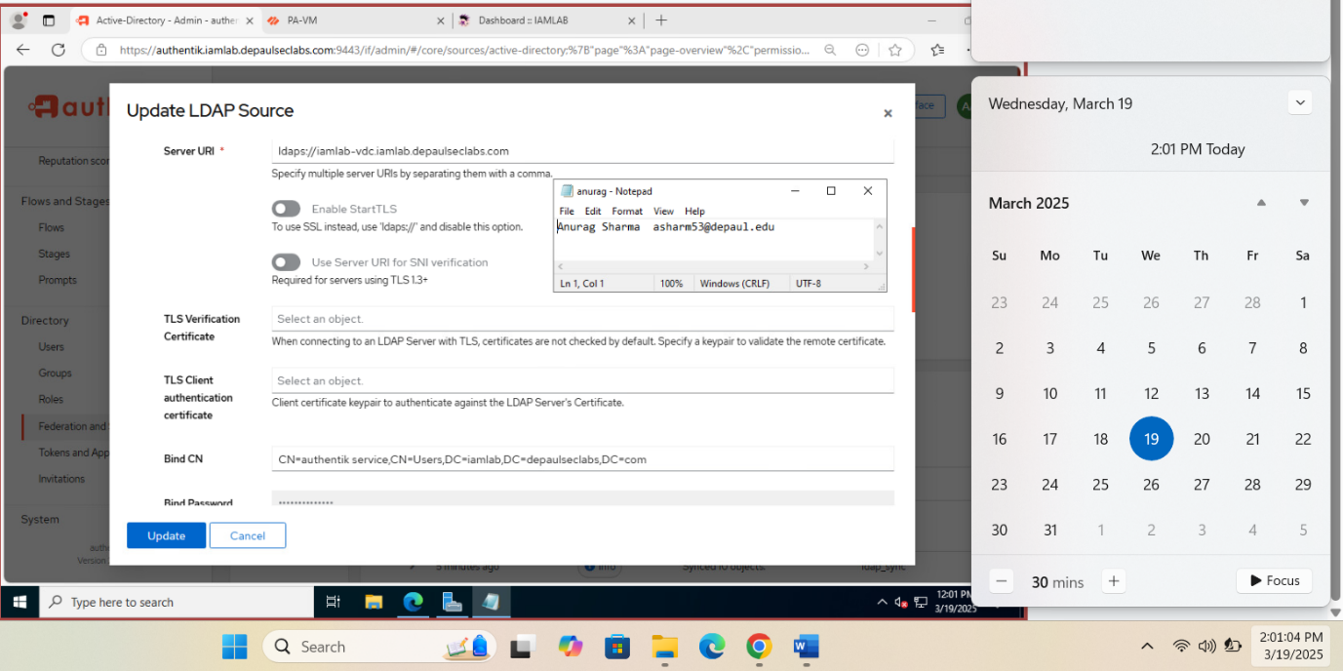

# **Screenshot of users synced to Authentik from LDAP**

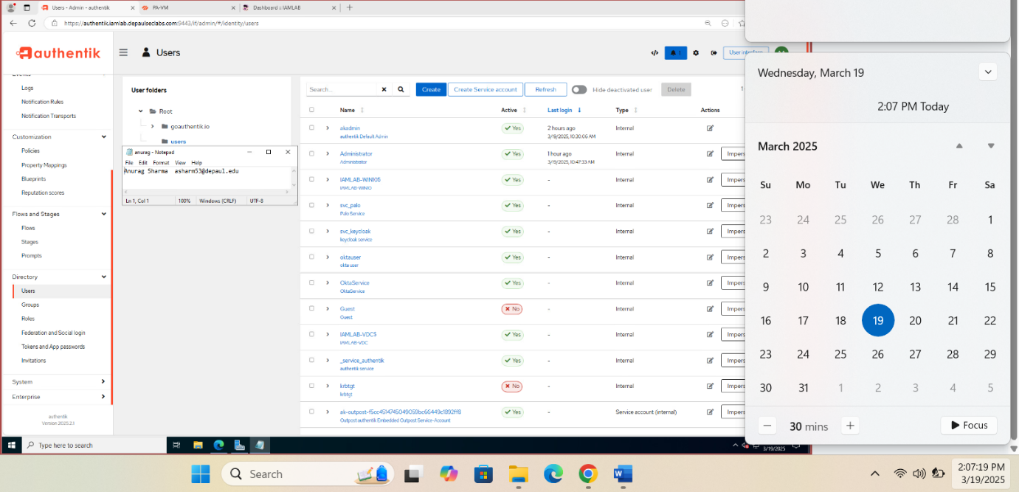

# **Screenshot of groups synced to Authentik from LDAP**

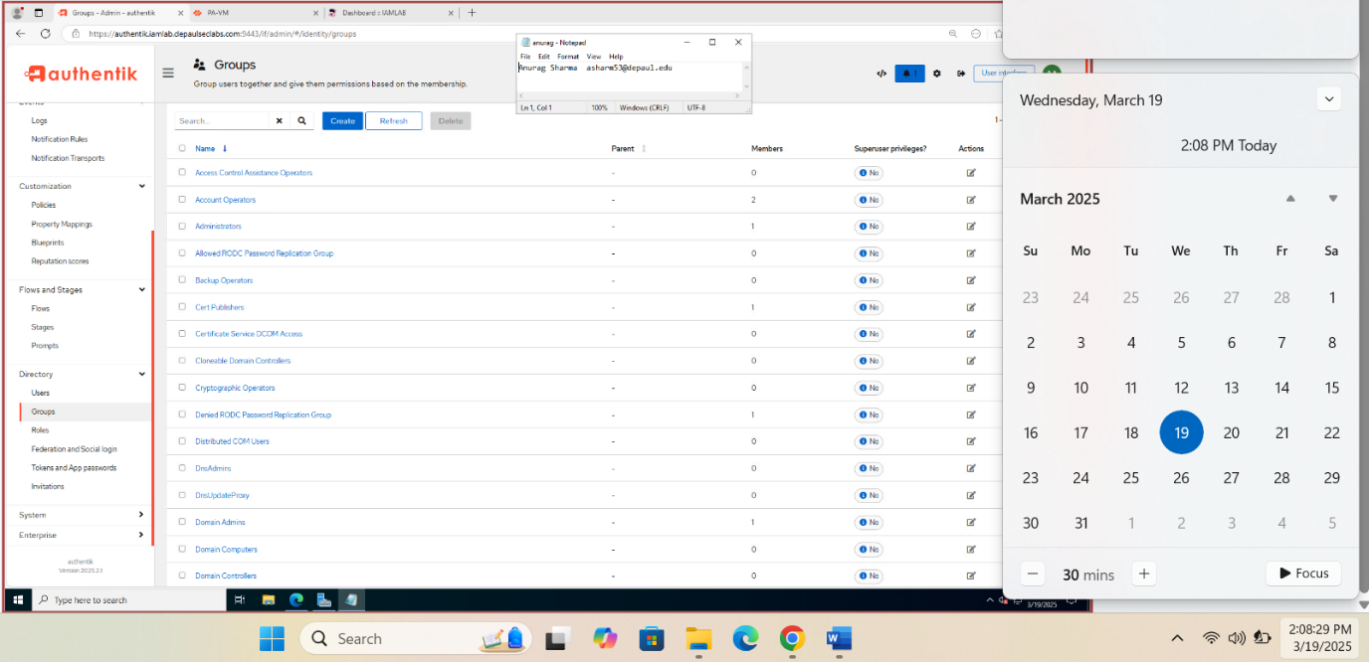

# **Screenshot of a browser connected to Authentik, and the certificate chain presented by Authentik**

# **Screenshot of SAML configuration used by SNIPE-IT showing Authentik as the IDP**

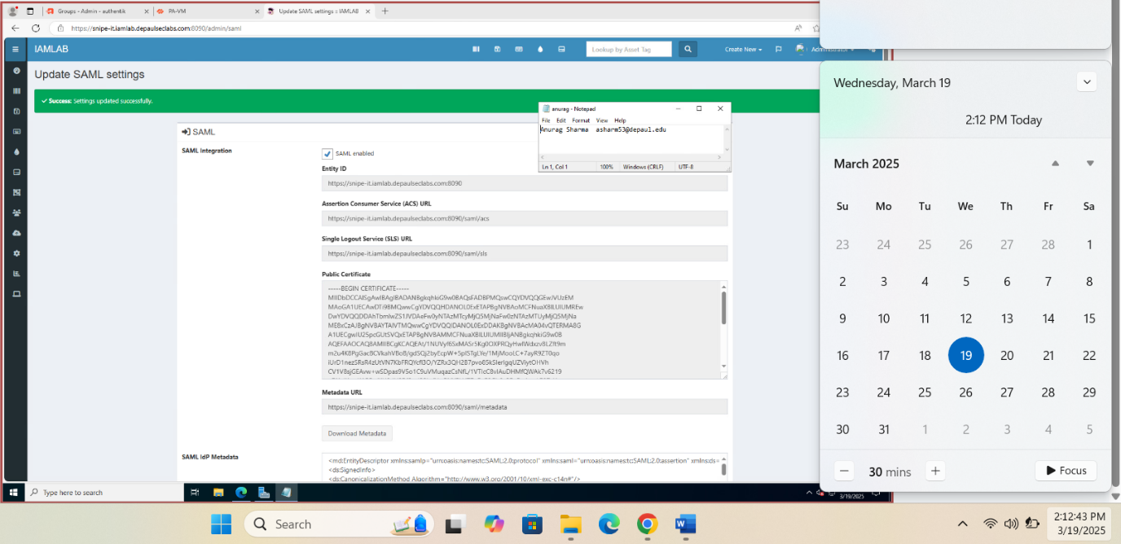

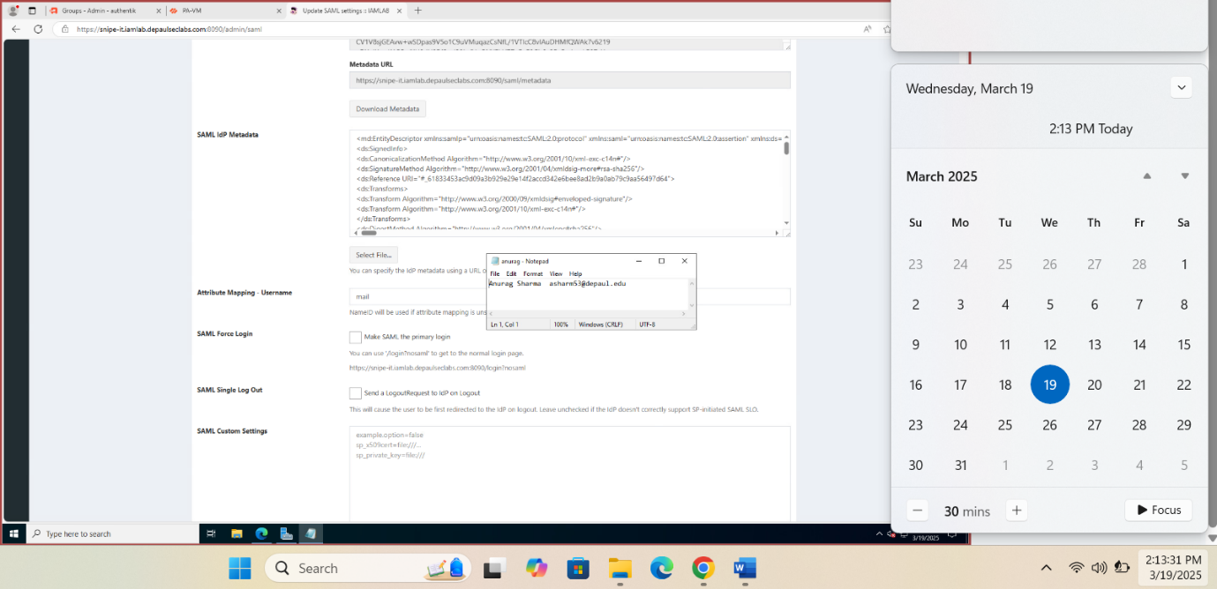

# **Screenshot of SAML Identity provider configuration on the Palo alto using Authentik as the IDP**

